AWS Task-1
AWS Task-1

Task Description:

Create a windows VM machine in AWS and connect with RDP open CMD in windows share the about system info.

Techstacks needs to be used :

- AWS EC2 (windows)
- RDP (Preavailable in Windows)

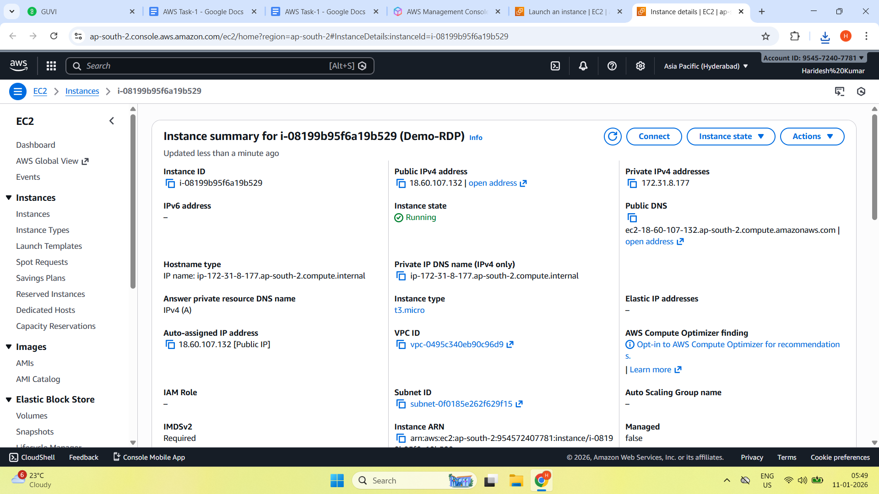

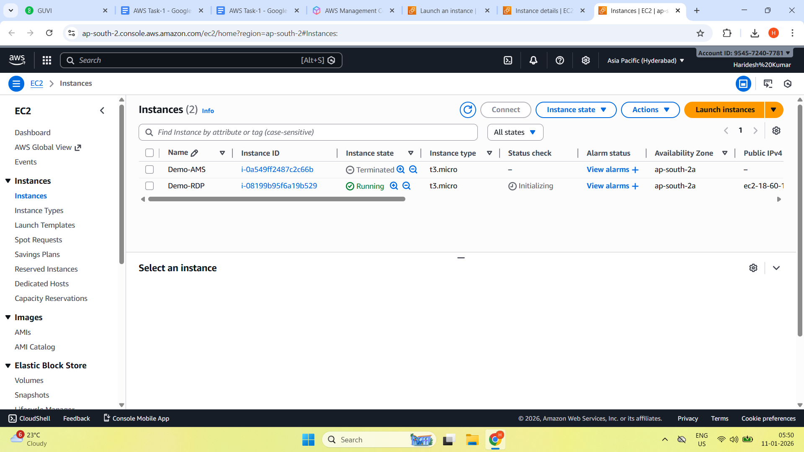

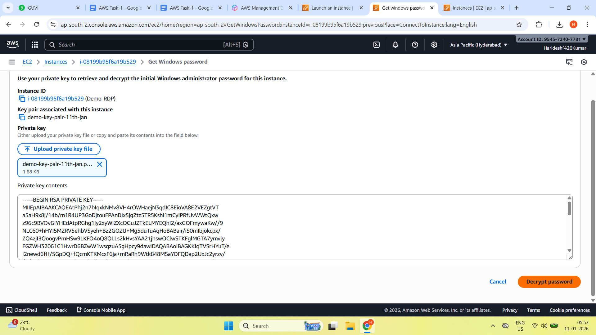

Successfully created a window EC2 virtual machine in AWS, connecting using RDP and retrieved system info using command prompt.

